**Assignment-2** **Prashanth.S(19MID0020)**

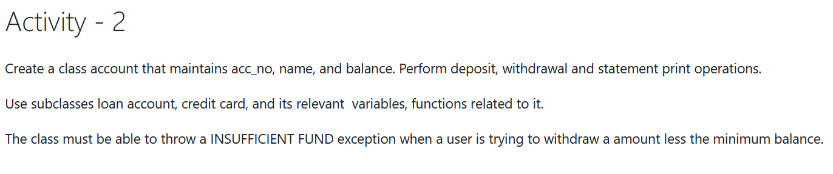

Over-view of Assignment-2

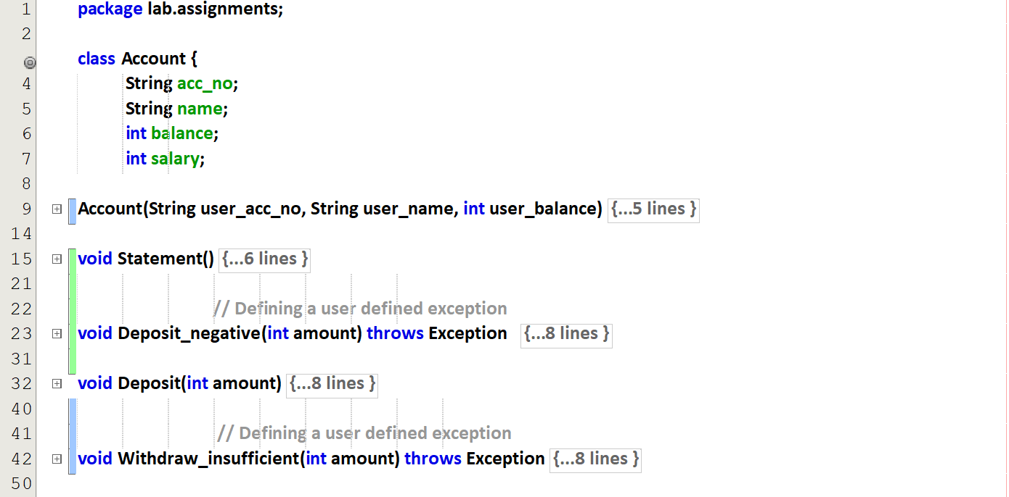  
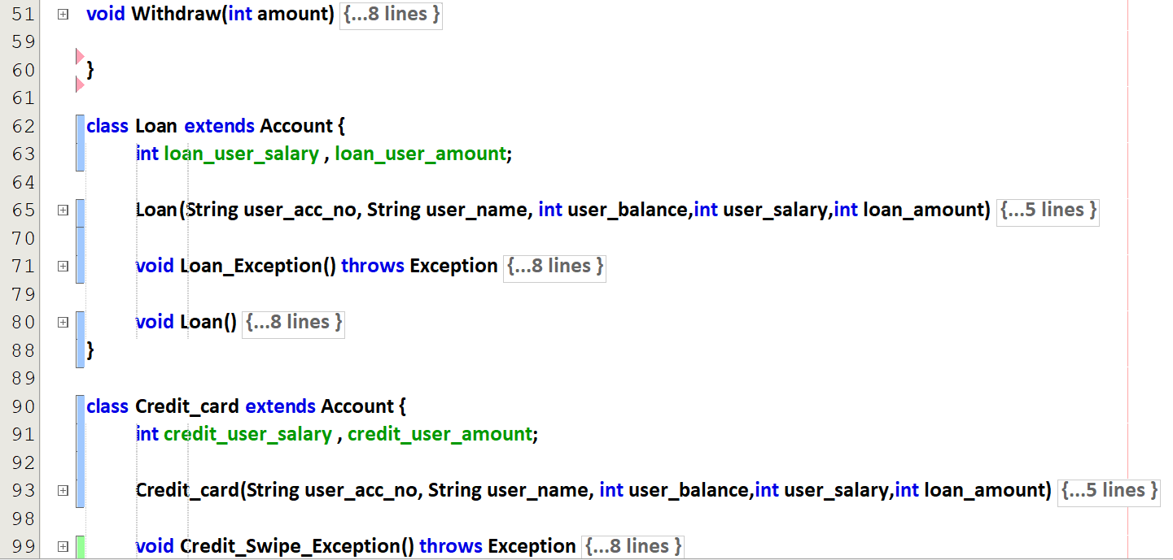  
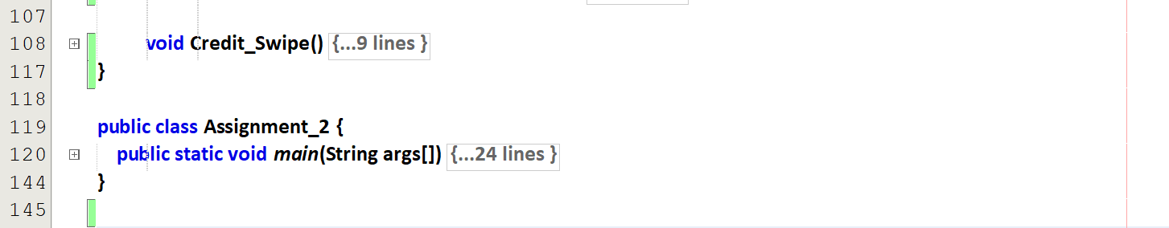

# Account class

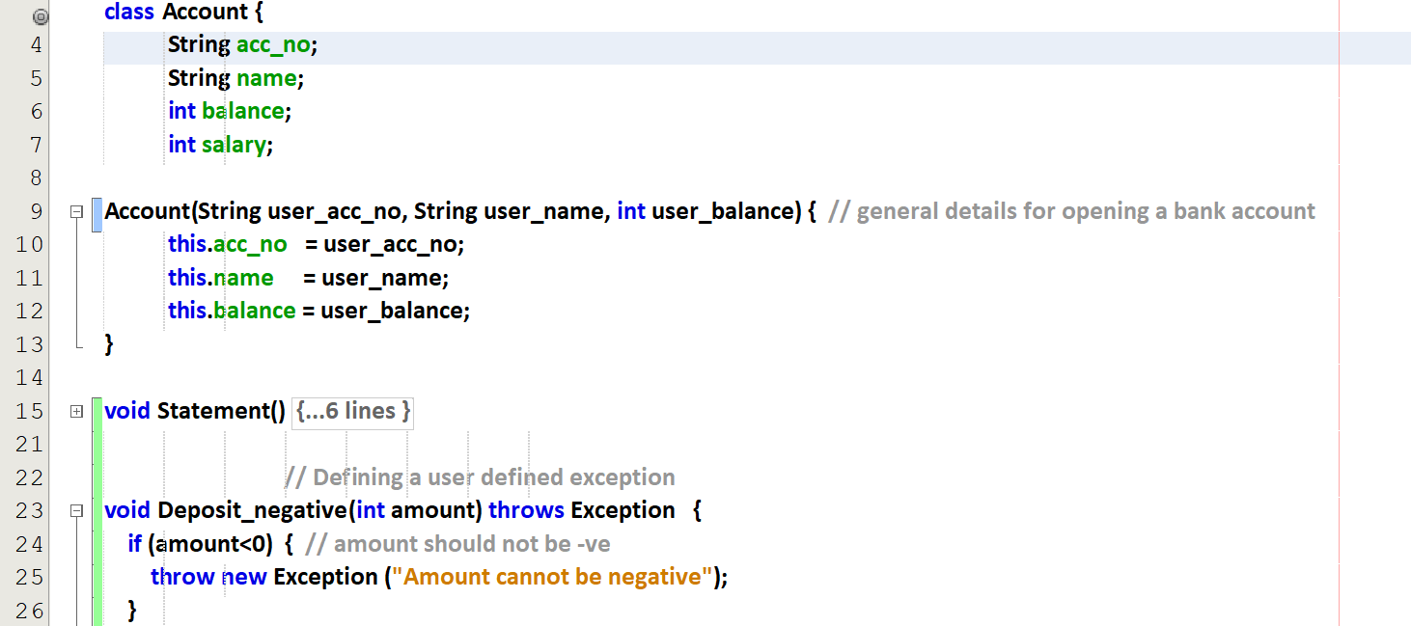  
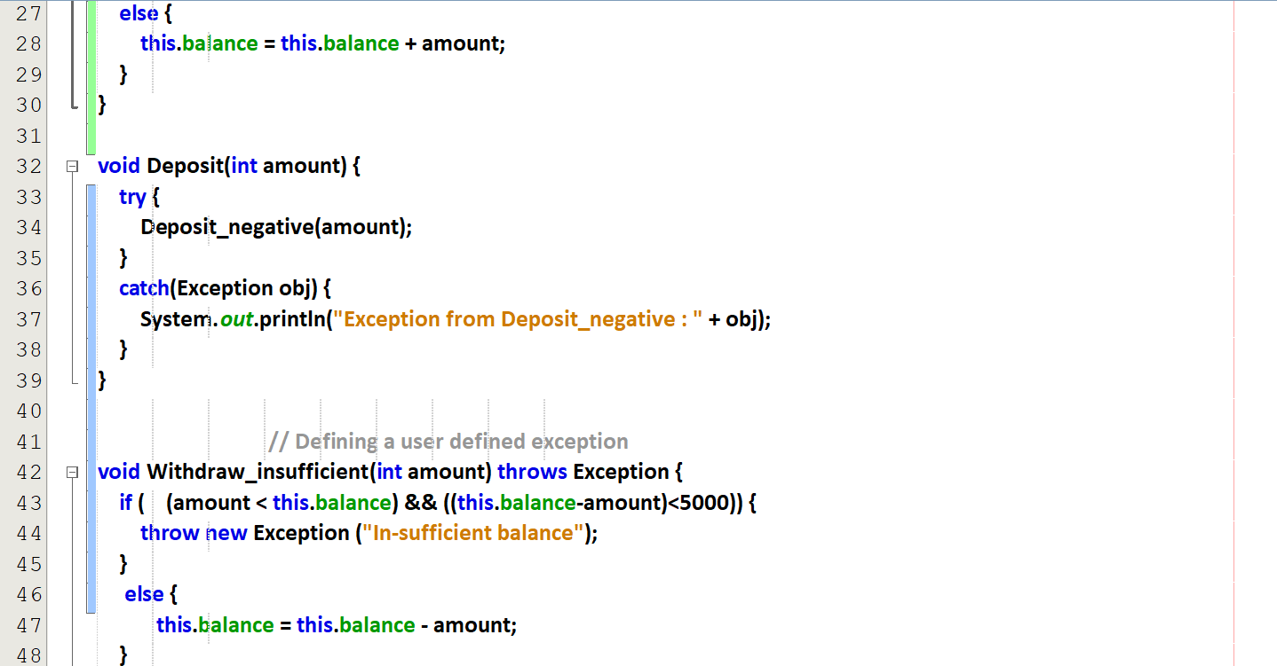  
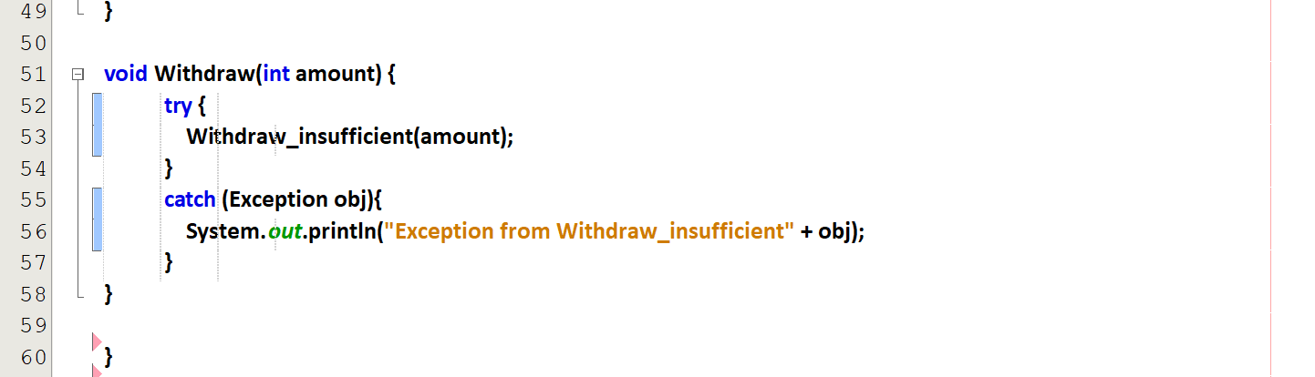

# Loan class

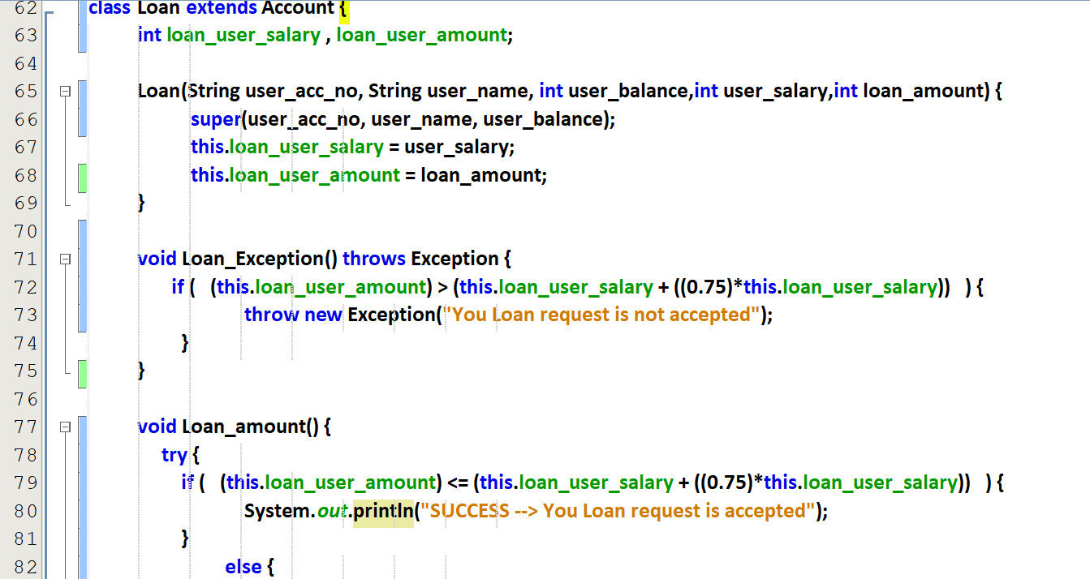  
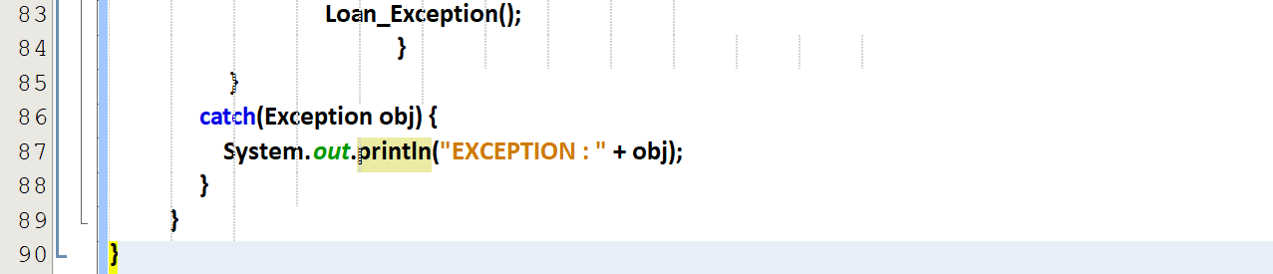

# Credit card class

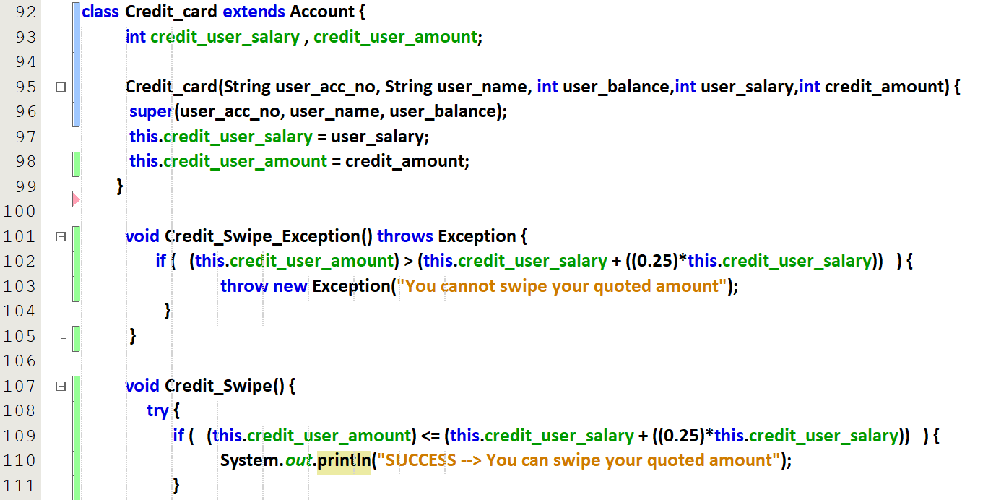  
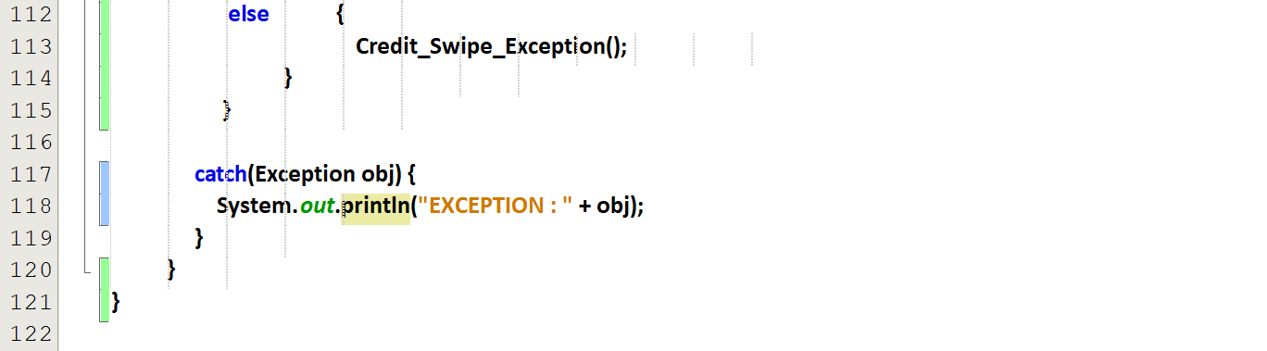

# Main method

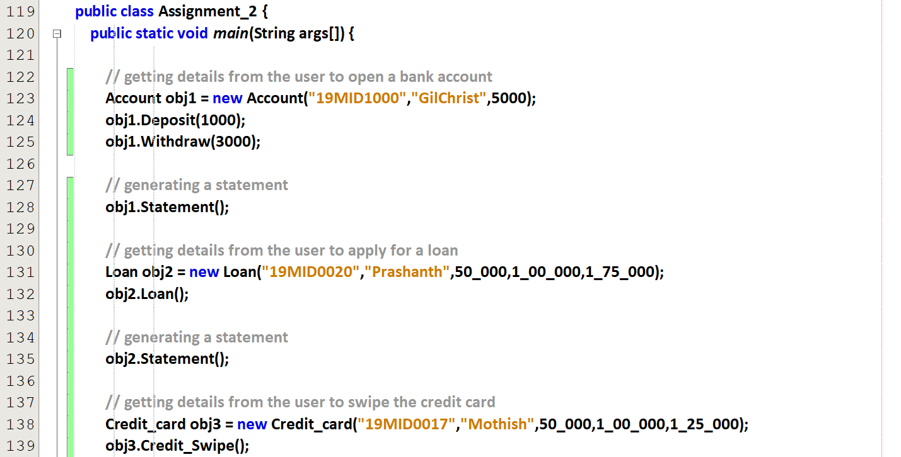  
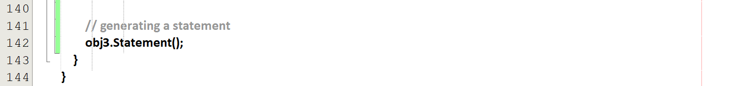

# Depositing and Withdrawing Procedures

## Depositing negative amount

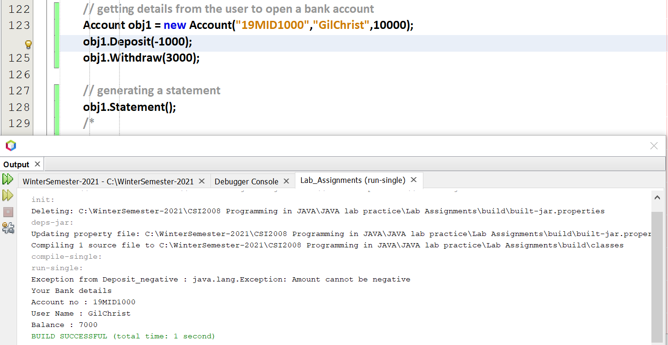

## Withdrawing amount which is greater than minimum balance

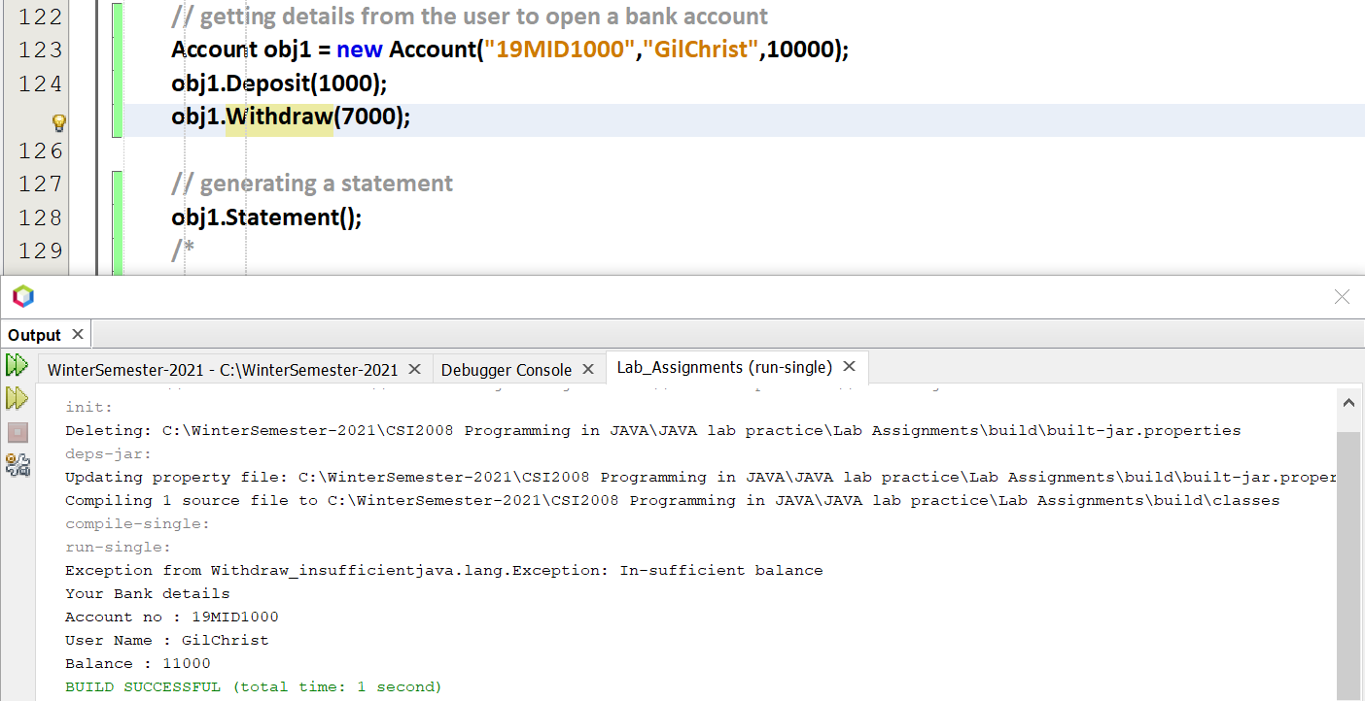

## With the above two exception

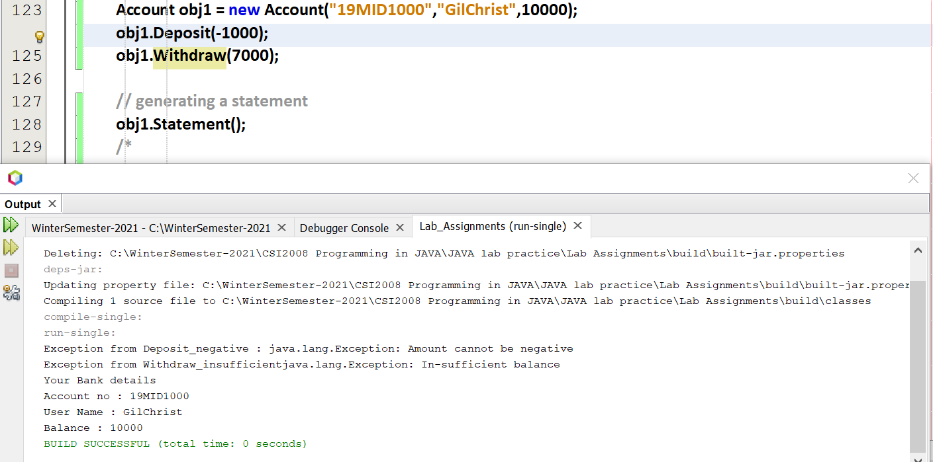

## Without the above two exception

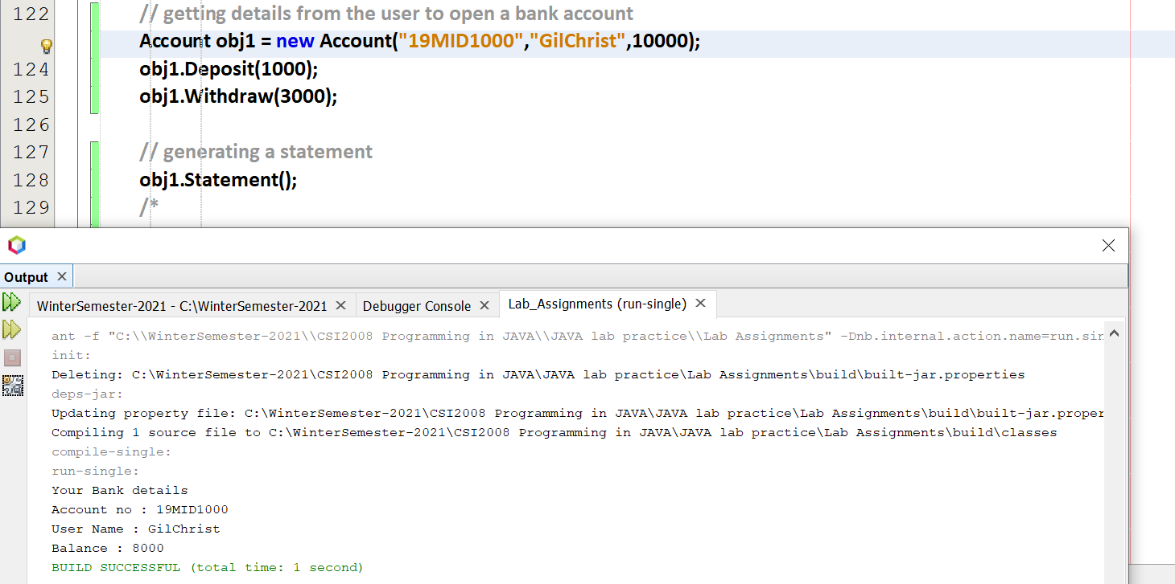

# Credit card and Loan Amount Procedures

Credit card 🡪 <= (salary + 1/4th * salary) 🡪 Approve

Loan 🡪 <= (salary + 3/4th * salary) 🡪 Approve

## Credit card Swiping more amount

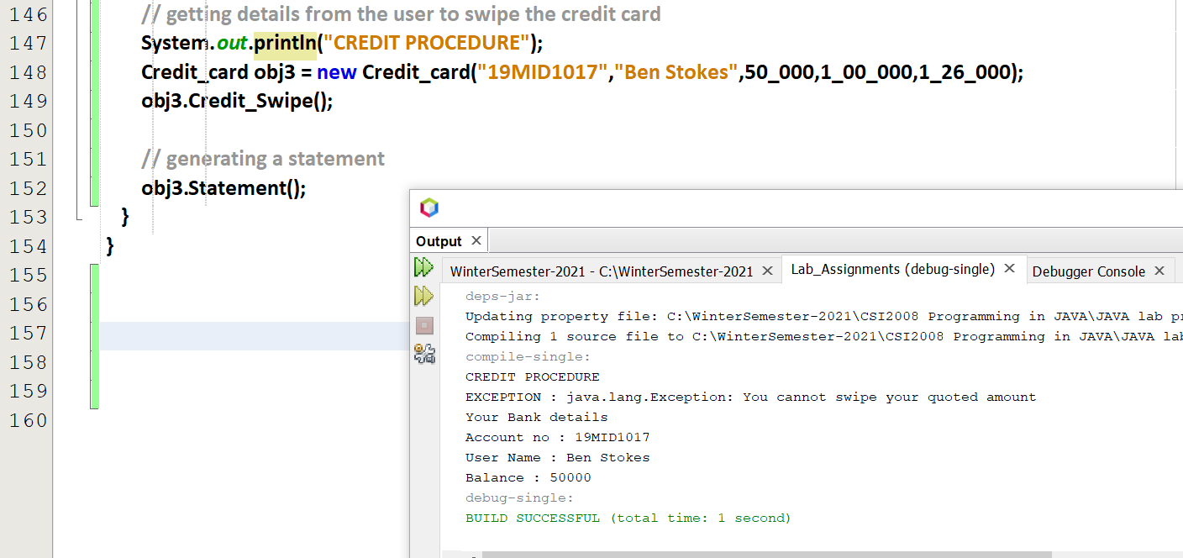

## Credit card Swiping less amount

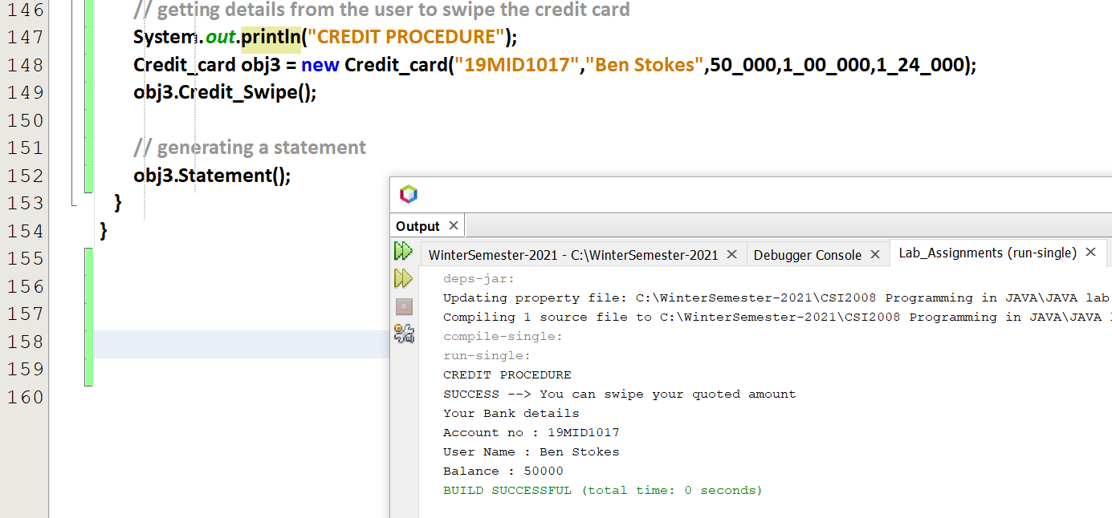

## Applying for more loan amount

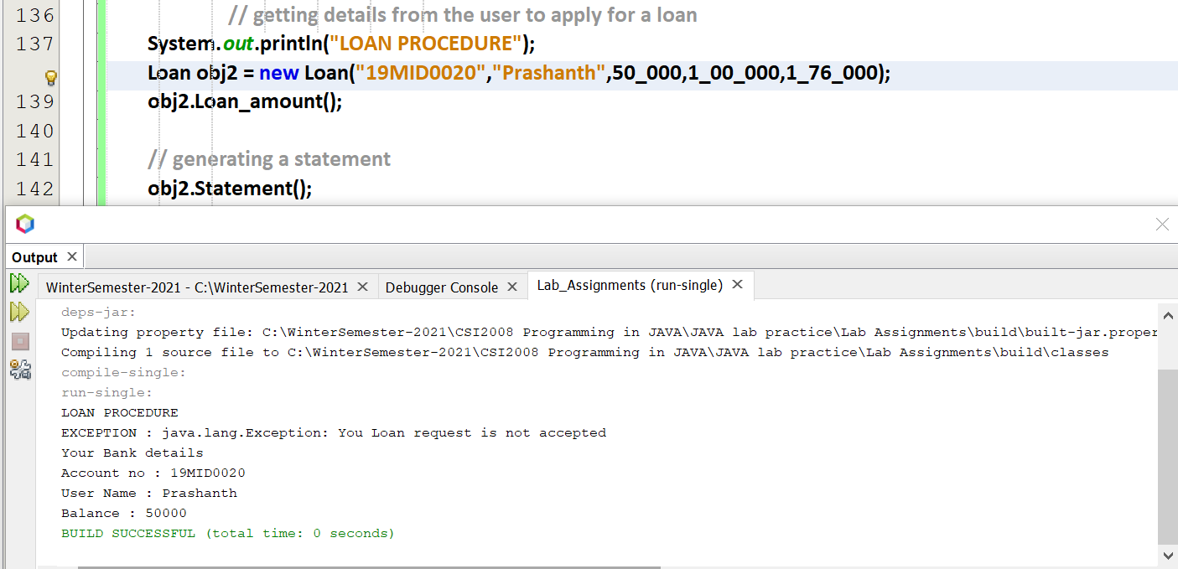

## Applying for less loan amount

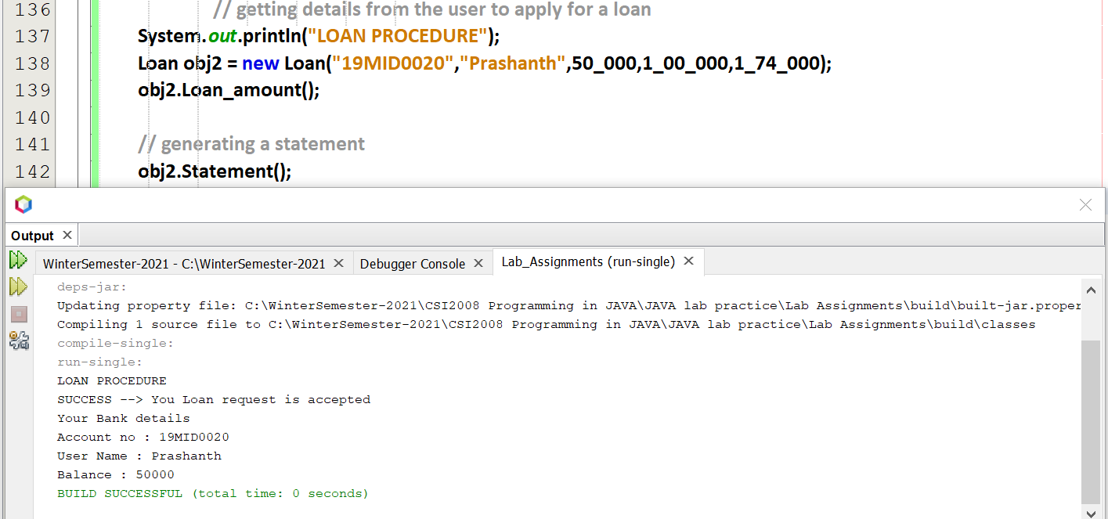

## Without the above two exception

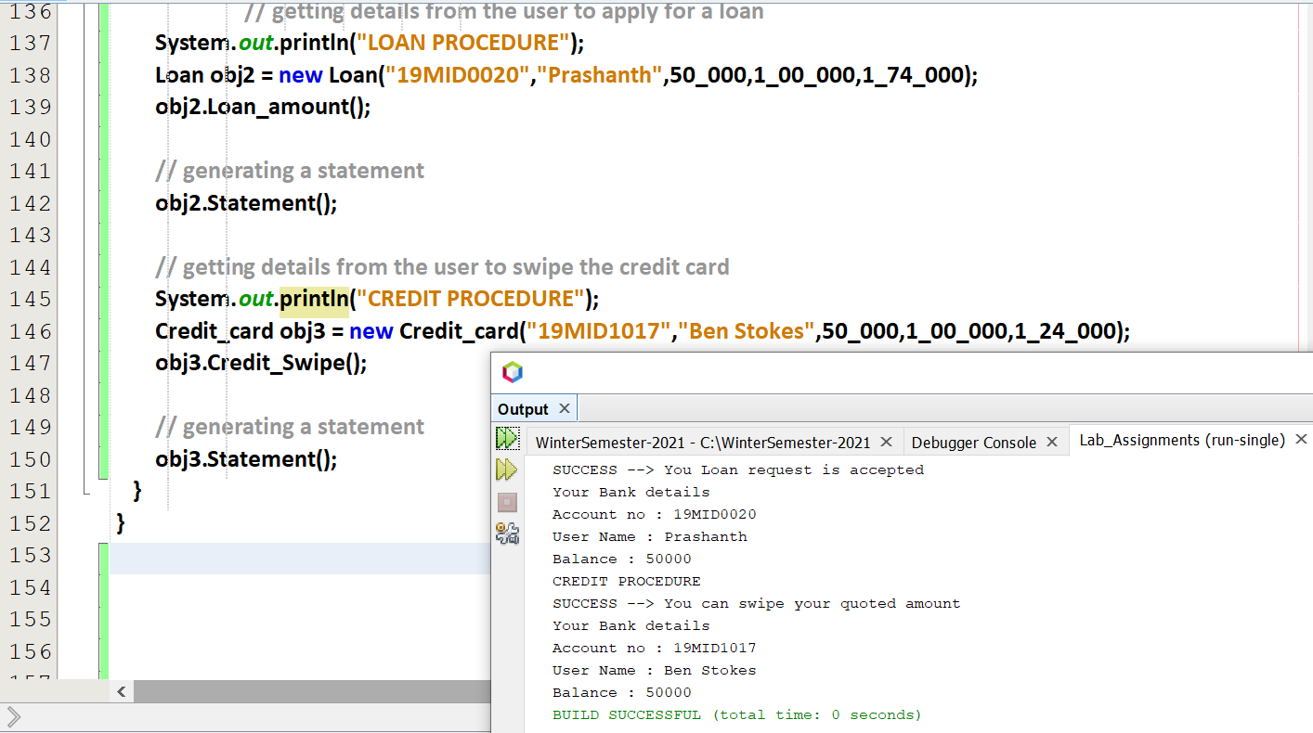

## With the above two exception

